5th SIMA AGRITECHDAY by AXEMA
*Please note that if your abstract is selected by the Scientific & Technical committee for an oral presentation, submitting a full paper is required and will be published in the book of the event. Full instructions will be sent afterwards.

Meaningful title of the article
Name and Surname¹, Name and Surname^{1,2}, Name and Surname³, …
¹ Affiliation…
² Affiliation…
³ Affiliation…

Keywords (no more than 6 words) :

Details about any of your own previous publications or presentations on this subject (If applicable) :

Request for:
- An oral presentation
Or
- A poster

How you contribute to sustainable agriculture (choose the most relevant goal among those of the United Nations) :

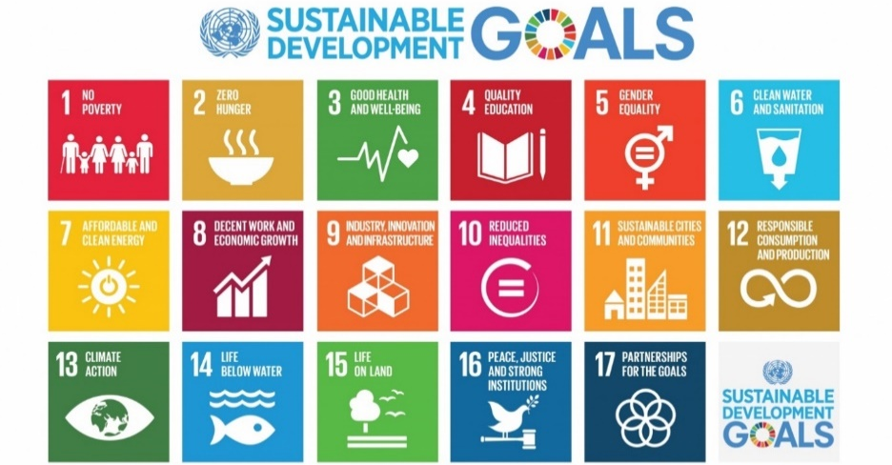

Summary:

The summary should be written in English with a word limit of 500 and must :
- Address one or several of the conference areas or topics
- Include background, purpose , methodology, results and conclusion
- Include theorical, modeling or experiment content

